University of Canterbury

Robocup Progress Report 3

Group 10

Jack Hendrikz  
Peter Nicholls  
Ryan Taylor

20 October 2015

# 0.0 Executive Summary

This evaluation report (ER) assesses the performance of Group 10s robot in the second annual package-collection Robocup competition. This competition is a challenge where an autonomous robot has 5 minutes to navigate and retrieve as many packages as possible within an unknown arena layout. Group 10 came fourth in a series of knock out rounds. The group competed in a total of four rounds, two of which were won, the other two of which were lost. During these rounds, the robot collected a total worth of food packages, equivalent to just over per round.

The method of package collection was to use three permanent magnets, and used a form of slider-crank to remove the packages from the magnets. Four infrared sensors and three ultrasonic sensors were used to navigate and search the arena. Once a package was seen, it took 0.5 seconds to collect it. The unique track layout could provide a top speed of approximately. When a package was collected, an array of digital IR sensors positioned above the magnets confirmed the collection.

This report evaluates the robot against the initial design requirements discussed in the conceptual and detailed design reports (CDR and DDR), followed by a comparison with the four robots challenged. The aspects of the robot that performed well were the permanent magnet collection method and the ground clearance. The two main ways the robot failed was that it could not drop off packages reliably, and the watchdog timer had not been tested in all cases.

The performance of other robots during the competition was variable, with both successes and failures. Group 3 had a robust mechanical magnetic pickup mechanism along with a simple storage and drop off system. Group 12 used speed to their advantage, along with a passive pickup mechanism. Group 6 in contrast had a terrible locomotion system, causing it to become lodged on uneven terrain at several points during the competition.

For the robot to have progressed further in the competition, a better watchdog timer and more reliable package detection should be implemented. This timer, used in tandem with the IMU’s accelerometer, would trigger if the robot had not accelerated for 10 seconds. This would only occur when the robot became stuck against arena obstacles. Package detection had a maximum range of and could be improved with the use of cameras and infrared diodes.

Table of Contents

0.0 Executive Summary 1

1.0 Introduction 3

2.0 Design Description 4

2.1 Locomotion 5

2.11 Mechanical Layout 5

2.12 Sensor Layout 5

2.13 Software Algorithms 5

2.2 Package Manipulation 6

2.21 Pickup Mechanism 6

2.22 Sensor Layout 6

2.23 Software Algorithms 6

2.3 Non-crucial Subsystems 7

2.31 Audio Amplifier 7

2.32 Switch bank 7

2.33 Light Array 7

3.0 Design Evaluation of Robot 8

3.1 General 8

3.2 Identification 8

3.3 Movement 9

3.4 Collection 9

3.5 Construction 10

3.6 Safety 11

4.0 Performance of Other Designs 11

4.1 Competitor 1 (Group 4) 11

4.2 Competitor 2 (Group 3) 12

4.3 Competitor 3 (Group 12) 12

4.4 Competitor 4 (Group 6) 13

4.5 Design Improvements 14

5.0 Conclusion 15

Contribution statements 15

Appendix 1 – Bill of Materials 16

Bill Of Materials (Provided) 16

Bill of Materials (Additional) 16

Bill Of Materials (Circuit 1) 16

Bill Of Materials (Circuit 2) 17

Bill Of Materials (Circuit 3) 17

Appendix 2 – Tournament Placings 17

# 1.0 Introduction

This the final report and assessment for the 2015 Robocup. The Robocup competition is a challenge where an autonomous robot must be designed to search and retrieve packages in an arena. The arena has a series of obstacles unknown to the team, and included walls, poles and uneven ground. The packages are placed in specific but unknown points within the arena, with varying collection difficulty. The packages were also of unknown mass, more mass being worth more points. Two robots competed to get the most mass from the packages.

Each round lasted 5 minutes, and if the winner could not be determined by the total mass collected, then the robot furthest from base would be declared the winner. The competition was structured as a double-elimination tournament such that the winner of each round would continue to the next round, and also allowed for one loss in the competition. The limit of three packages on board meant returning to base was essential to getting more than three packages.

For this to be accomplished, there are many crucial sub-systems that are required to work in unison. These can be split into two main categories:

* Locomotion - how the robot will move, avoid walls and return to base
* Package Manipulation - how the robot will detect, collect and release packages

Both of these require detailed software, electronic interfaces, sensors and mechanical interfaces with the environment. There are also several non-critical subsystems which will also be discussed in lesser details. Such subsystems include the three constructed PCBs.

This report will analyse several aspects of the finished robot, starting with a how it compares with our previous designs in the CDR and DDR, and secondly it's performance in the arena. The performance of our robot against that of four other competitors will also be analysed. Final suggestions for the future evolution of the robot will be put forward as if it was to compete again.

# 2.0 Design Description

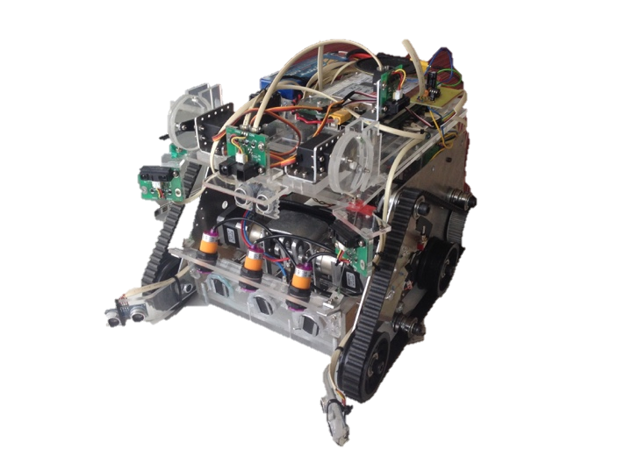

Figure 1: The final design used in the competition

The final robot design is shown in Figure 1. Three permanent magnets were used to collect and store packages, which could then be raised and lowered using two servos. One ultrasonic and four infrared (IR) sensors were used for navigation, two ultrasonic sensors were used for package detection, and three digital IR sensors were used to detect when a package was on board. 3D printed wheels provided the robot with good ground clearance and greater mobility.

The software we used had effective wall and object avoidance, but had inefficient package detection. Because the ultrasonic sensors used for package detection were noisy, a compromise between response time and accuracy had to be made. Unfortunately we were not able to reliably detect packages which lead to time being wasted by driving past them. Figure 2 shows the overall flow of software used in the competition. The software set a target in Cartesian coordinates to drive towards, which took into account the walls, packages and bases. Using Cartesian coordinates made it easier when linking the sensor information input to driving output.

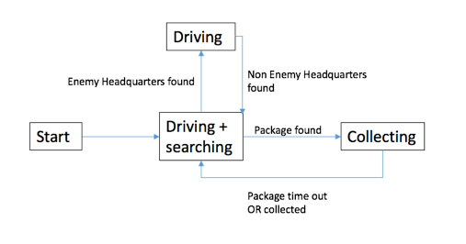

Figure 2: The final flow of software

## 2.1 Locomotion

### 2.11 Mechanical Layout

The bumps were high and 3D printed wheels were used to raise the minimum height of the robot to. Having a shortened wheel base improved the turning speed and mobility of the robot. Although this model did not give a speed advantage, the robot was fast enough that the drive wheels did not require modification. Figure 3 shows the robot track design with the centre of gravity. The track layout was left as described in the CDR and DDR.

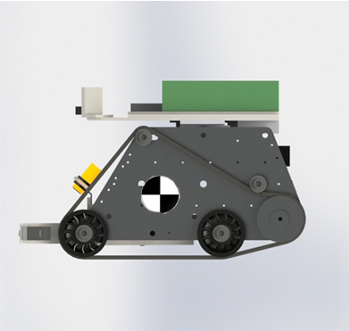

Figure 3: Track configuration and centre of gravity of the robot

### 2.12 Sensor Layout

One ultrasonic and four IR sensors were used to navigate the arena and avoid obstacles. Two medium IR sensors were mounted on the front of the robot and set at an angle of 27 degrees from the centre-line of the robot. This ensured that they would intersect with the ultrasonic sensor beams which enabled them to be compared. This comparison helped the robot distinguish between obstacles and packages.

The long range IR sensor was mounted in the middle front of the robot and helped with terrain navigation. It was predominantly used to detect corners and allow the robot to move through gaps. It could also be used for pole detection if the robot was approaching the pole.

The centrally mounted ultrasonic sensor was added to compliment the long range IR as it is more effective at detecting poles. This helped ensure that the robot would not become stuck on the poles around the arena. An extra short range IR was mounted on the top of the robot facing left. This aided wall avoidance and helped determine whether it was approaching a corner or not.

### 2.13 Software Algorithms

The software had a series of cases for different sensor readings, each of which would place the target in a different position. This was done approximately every. Each case compared the sensor values to determine the layout of its surrounding environment, and made suitable navigational decisions. This made it easy to debug each case the robot encountered. There were a total of 16 different cases.

A watchdog timer was also coded to prevent the robot from becoming stuck on obstacles around the arena. To implement a watchdog timer, the location of the target was monitored. If the target had not moved for six seconds, then the robot reversed and then rotated. This method worked well when the robot was stuck in a corner, bump or pole, but caused issues in the presence of another robot, and is discussed later.

This algorithm implemented the secondary tactic, as opposed to the primary tactic due to time constraints. This tactic was described in the DDR but would only be utilised if the primary tactic failed.

## 2.2 Package Manipulation

### 2.21 Pickup Mechanism

The pickup mechanism used three permanent magnets to retain the packages. When a package was detected the robot would lower the magnets ready for collection and once the package was on board it would subsequently raise the magnets. A system was in place to retract the magnets, allowing them to be detached when the mechanism was retracted. In doing so, the magnetic force would be smaller than gravitational force on the packages, thus dropping the packages. Two geared stepper motors (FIT0349) were used to operate the system which converted rotational motion to linear motion. Figure 4 shows the pickup mechanism design with the magnets on the front and digital IR on the front. Figure 5 shows a section view of the mechanism. As the geared stepper rotates the eccentric shaft is spun around, which makes the link rotate back and forward. The magnets are connected through the rod to the link, providing linear motion. Feedback was achieved as to when the magnets were extended by a limit switch, and when a package was being stored by the digital IR sensors. The only changes to this system from the DDR was the addition of a limit switch and reinforcing brackets.

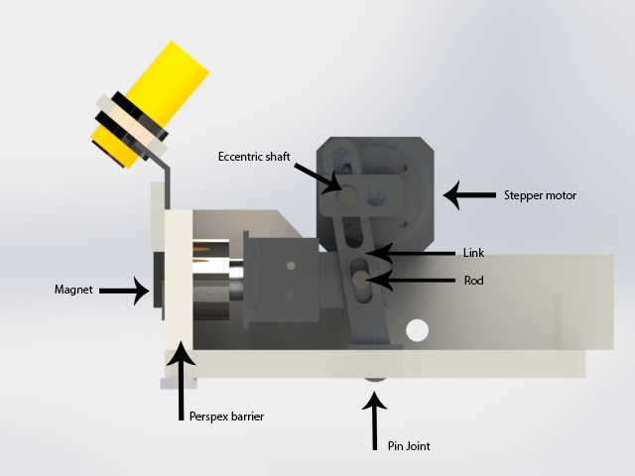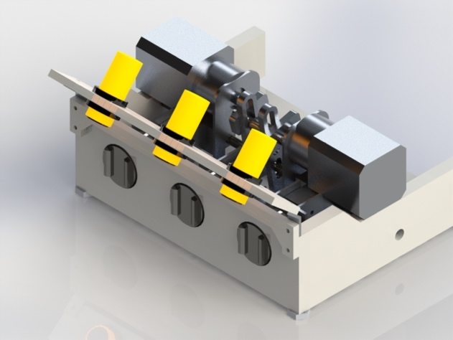

Figure 4: The overall pickup mechanism

Figure 5: Components within the pickup mechanism

### 2.22 Sensor Layout

Ultrasonic sensors were used to find packages, they were mounted 40mm above the floor in front of the robot. When choosing the angle, if the angle was larger, the robot had a reduced range but had a wider field-of-view. They were placed at an angle of 50 degrees so the viewing angle was a total of 130 degrees. While it could not see packages in the 70 degrees in front of it, these package would fall within view of the ultrasonic sensors at some point. This was as outlined in the DDR.

### 2.23 Software Algorithms

When one of the ultrasonic sensors registered a distance, it would read the IR and ultrasonic sensors on top of the robot and determine whether or not the point given was a wall, pole or package. If it was a package, then the distance was calculated from the difference between ultrasonic sensors and IR sensor, and then the relative Cartesian coordinate would be computed.

When a package was detected, the robot placed the target on top of the reading. To reduce the effect of 'false positives' given by the ultrasonic sensors, three checks were done. Firstly, the robot would only decide that a package was indeed a package after detecting it three consecutive times. Secondly, the amount of time spent chasing the package was directly proportional to the number of times detected. This allowed time to pick up the package once in the robot's inner blind spot. Thirdly, when aligning with a package, the robot would move slower. This was good as it has reduced probability of driving into walls, but it also made it much slower when nearing a package (as the speed was proportional to the distance from the target).

Because there were three digital IR sensors which could determine which magnets had collected packages, the robot could aligned such that the packages would collect on the empty magnets. When all three digital IR sensors were active, the robot would not attempt to collect packages. The robot would also not collect packages when it either base. This was how the DDR described the package detection.

## 2.3 Non-crucial Subsystems

### 2.31 Audio Amplifier

Since the Arduino is not able to supply much current, attaching a speaker straight to the pins could not provide the volume wanted. The amplifier board was so successful that while it was not receiving a signal, it would amplify the electrical noise generated by the fan. To prevent this, a transistor was used to enable or disable the speaker. This meant it would be enabled only when it needed to be used.

### 2.32 Switch bank

The bank of eight switches was a useful addition to the robot which ought to have been implemented earlier. Although it wasn't really used in the actual competition, it was very useful when testing. Each of the switches were bound to a different statement in code which enabled different behaviours such as whether or not to release packages and disabling the motors. Each of these were useful when testing.

### 2.33 Light Array

This was initially intended to contain a bank of IR LEDs as well as mount the IR camera, there was not sufficient time to implement the camera. As such, the IR LEDs were not required, so standard LEDs were used for nothing more than to confuse other robot's cameras.

# 3.0 Design Evaluation of Robot

## 3.1 General

#### R1.1 The robot will be fully autonomous ✔

#### R1.2 The robot will be controlled by the Arduino Mega ADK supplied ✔

#### R1.3 The robot shall be able to move, identify and collect packages ✔

#### R1.4 The robot shall operate until all 11 packages are claimed or the time limit is reached ✔

The robot was fully autonomous throughout the competition through the use of the supplied Arduino Mega ADK as specified in R1.1 and R1.2. The robot had the ability to move, identify, and collect packages within the arena with the use of ultrasonic sensors as per R1.3. During the tournament, the robot collected seven packages, weighing a total of. Although the robot collected this many packages, there were another approximately 20 packages that were either not detected (and should have been) or unable to be collected at all. This gave the robot a successful collection rate of 35%.

The robot fulfilled R1.4 as it operated for the full five minutes that the match lasted. There were not issues with the robot running out of power during operation, but the robot was immobilised during the third round. It could be noted that there was no counter implemented to instruct the robot to cease package detection after all 11 packages had been claimed.

## 3.2 Identification

#### R2.1 The robot shall be able to identify food packages ✔

#### R2.2 The robot shall be able to identify obstacles it cannot move over ✔

#### R2.3 The robot shall be able to distinguish home HQ and the opposition HQ ✔

#### R2.4 The robot should rely on a range of navigational sensors ✔

The robot could identify packages as per R2.1, however it did have reliability issues. It detected approximately 60% of the packages within the sensors’ range, but there were also several false positives detected. The arena walls had a curved skirting which on occasion would be read as a package. Poles were also another obstacle that would flag a false positive due to the offset of the ultrasonic and IR sensors. While they were placed to reduce false positives, there was a small region in front of the robot that is detected by the ultrasonic sensor but not the medium IR sensors, and was hence interpreted as a package. This meant that the robot moved towards what the false ‘package’. Once the robot was close enough, the sensors could not read accurately. This is when the watchdog timer kicked in and caused the robot to reverse and turn. The false positives could have been reduced through the additional use of an alternative package detection system.

The robot performed well when it came to identifying its surrounding environment. The use of four different types of navigational sensors satisfied R2.2 and R2.4. A total of five sensors were used for navigation along with two sensors for package detection. This sensor array meant the robot reduced collisions with the arena to approximately four per minute. The only problem encountered during the competition when navigating was that the robot often steered towards poles (as discussed previously), which raised this collision rate to over six per minute.

Once calibrated, the robot could accurately distinguish between home HQ and opposition HQ. This was achieved via the Adafruit TCS3472 colour sensor mounted on the underside of the robot. The robot never attempted to collect a package in either base, and so R2.3 was satisfied. Overall the robot's environment detection performed well at a basic level during the competition, but could have functioned more robustly with more comprehensive calibration and testing.

## 3.3 Movement

#### R3.1 The robot shall be able to move over obstacles at least 25mm in height ✔

#### R3.2 The robot shall be able to fit through gaps of at least 500mm in width ✔

#### R3.3 The robot shall be able to manoeuvre around obstacles it cannot move over ✔

#### R3.4 The robot shall not leave the designated arena during the competition ✔

#### R3.5 The robot should not get stuck in any algorithmic loops for longer than 1 minute ✘

The design of the locomotion allowed the robot to operate well within the arena during the competition. The 3D printed wheel and track design allowed the robot to drive over obstacles at a speed of about as per the requirements of R3.1. The design was kept compact, allowing the robot to move through arena obstacle gaps of at least, specified in R3.2. Once obstacles too large to move over were detected, the robot could navigate efficiently around them, thus fulfilling R3.3. There was no physical way that the robot could leave the arena during operation, meeting requirement R3.4.

The robot did suffer from a few design issues, one of which was that the tracks detached occasionally, once during the competition. This only happened on uneven terrain, as the belts lost tension and subsequently slipped off the wheels. This could have been avoided through providing more belt tension and installing brackets to prevent the belt from slipping off the wheels.

During testing it was noticed that the front of the aluminium chassis would flex outwards by on both sides. This flexing was put down to the belt tension and lack of bracing on the front of the robot. Bracing was difficult to achieve as it would have obstructed the pickup mechanism. Side bracing could have solved this issue, but there was insufficient time to test this solution.

For R3.5, steps were taken to prevent the robot from getting stuck in algorithmic logic loops for longer than one minute, however, not all issues were remedied before the competition day. A watchdog timer was implemented to prevent the robot from becoming stuck on terrain in the arena. This worked when stuck against terrain, but had not been tested with another robot. As the opposition robot moved, the robot's target would change and therefore reset the timer. In addition to checking the change in target, the accelerometer could have assisted in detecting when the robot had stopped.

## 3.4 Collection

#### R4.1 The robot shall be able to pick up a package so that it is under the robot’s control ✔

#### R4.2 The robot shall have a way of carrying, at most, three packages without hindrance ✔

#### R4.3 The robot shall not collect any packages within the opposition’s HQ ✔

#### R4.4 The robot should be able to release any packages it has on-board to HQ ✘

#### R4.5 The robot should be able to pick up packages in any orientation and any part of the map ✘

The collection mechanism of the robot performed well in the arena, and was the sole reason that the robot succeeded on the day. The versatility of the permanent magnets allowed three packages to be picked up under the robot's control, thus fulfilling R4.1 and R4.2. Two HX12K servo motors were used to lift the pickup mechanism for two reasons: so that the packages did not catch on uneven ground, and to prevent collection of opposition packages within their HQ. This meant that the robot also met criteria R4.3 during the competition.

The robot was programmed and designed so that packages could be dropped off in its HQ when the corresponding colour was detected. The magnet strength was underestimated during the calculation phase of the robot, preventing reliable package removal. This still would have been sufficient to remove some packages, but the mechanism would try to retract within the arena during last minute testing. This was either due to final changes in code or the lighting conditions. As such, the magnet retraction was disabled for the competition, which wasn't a big issue as the robot never collected three packages at one time. Even though functionality was there to remove the packages, it was not implemented during the competition and does therefore not meet R4.4. The packages also had a tendency to rotate when attached to the robot, making it difficult for other subsequent packages to be retrieved, which is the primary reason why the robot did not collect more packages in two of the rounds.

The robot could successfully pick up packages in any orientation in the arena but could not always collect packages placed close to obstacles as required by R4.5. It could not pick up packages near walls due to the wall avoiding aspects of the program. This could be helped by improving the package detection system, allowing the robot to get nearer to walls. It also could not collect packages on the opposite side of uneven ground as the pickup mechanism obstructed movement when trying to collect packages. This would most easily be fixed with a skid to mechanically lift the mechanism on uneven ground.

This robot had one of the most efficient pickup mechanisms, being able to collect a package in 0.5 seconds, rivalled only by Group 12’s mechanism. The average mass of packages collected per round was, which was nearly half that of our robot, which collected an average of.

## 3.5 Construction

#### R5.1 The cost of additional items shall not exceed $50 (except for R5.2) ✔

#### R5.2 Each member shall design their own PCB for use on the robot, not exceeding $5 ✔

#### R5.3 The robot should be built with less than 200g of 3D printer plastic. ✔

#### R5.4 The robot shall be easy to maintain and disassemble ✔

The construction of the robot met all the requirements. The additional components came to a total of $32.50, thus remaining under the limit of $50 as required in R5.1. A bill of materials can be seen in Appendix 1. The circuit boards designed were an amplifier circuit, an LED bank, and a dip switch circuit. Each circuit was built for less than five dollars, which satisfied R5.2. The 3D printed wheels used had a combined mass of, thus meeting R5.3.

Once the mechanism allowing the packages to be lifted or lowered was added, it was slightly harder to disassemble the robot. This was not a major problem and did not significantly hinder the ability to maintain or disassemble the robot. Therefore, the robot met specification R5.4.

## 3.6 Safety

#### R6.1 The robot shall not cause any deliberate damage to anything or anyone ✔

#### R6.2 The robot shall have an accessible ‘off’ switch ✔

#### R6.3 The robot shall use the battery safety circuit provided ✔

The robot was designed to minimize potential safety risks during operation inside and outside of the arena. Parts that were moving were difficult to access, making it hard to injure people or damage other robots. Machined components were sanded to remove all sharp edges. This ensured that the robot could meet specification R6.1. The power switch was place on the inside of the robot for easy access to meet R6.3 whilst being protected from opposition robots. The off switch ensured that the robot could be powered down at any time. The provided battery circuit was implemented as specified in the competition briefing, therefore the robot met criteria R6.3. Overall the robot design was very safe with minimal potential health and safety risks.

# 4.0 Performance of Other Designs

## 4.1 Competitor 1 (Group 4)

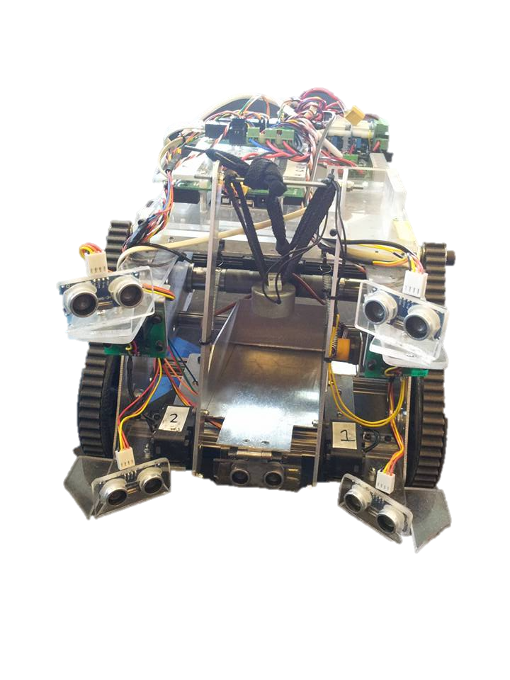Group 4 employed the use of an electromagnet setup on a crane system (see Figure 5). The robot would approach the package and line up using ultrasonic sensors. Once in position, the crane was extended and the magnet was switched on, allowing the package to be collected. The robot's speed was approximately. Obstacle avoidance was achieved via two front mounted long range IR sensors.

Figure 5: Group 4 robot

Package detection was achieved via five ultrasonic sensors. The upper ultrasonic sensors were compared with the lower ultrasonic sensors, as our robot did. The robot would then line up and centralise using the lower sensors. Once this was done then the central ultrasonic sensor was used to determine distance. Packages could be detected at a distance of approximately, however the field of view was limited. The robot could align and pick up a package in around five seconds. Packages could be picked up in any orientation, however the robot had difficulty detecting fallen packages. As quite a few packages were knocked over during the competition, it was difficult to determine the number of successful collections after package detection.

During the competition this robot could pick up packages well once they were detected. The speed of package retrieval was one of the main issues with this robot, as it was much slower compared to ours. Obstacle avoidance was also an issue as the only two long rang IR's were used. Our robot too could have used electromagnets, which would have simplified the pickup mechanism significantly. In summary this design would have functioned better wither more accurate obstacle and package detection.

## 4.2 Competitor 2 (Group 3)

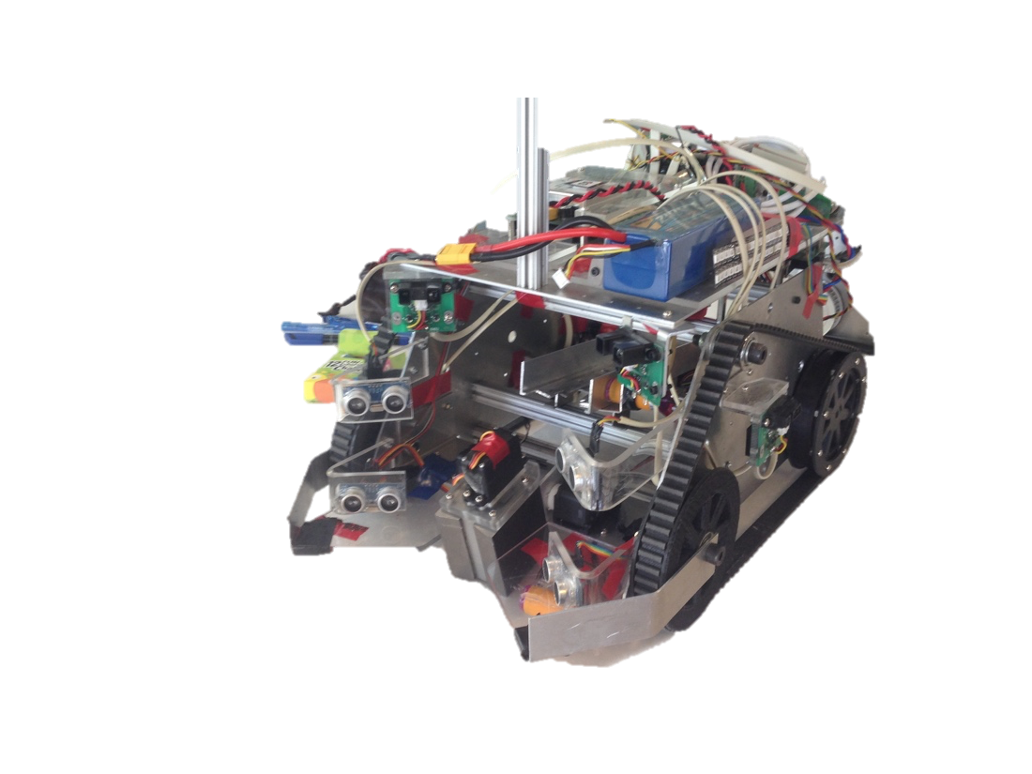Group 3 employed the use of a switchable permanent magnet that could be switched on or off depending on the orientation of the stepper motor (Figure 6). The robot would align itself with the package and engage the magnet. Next, a smart servo was used to lift up the package and place it on board the robot. The robot's travelling speed was approximately. Obstacle avoidance was achieved via two cross long range IR sensors and side mounted IR sensors.

Similar to other designs, package detection was achieved by ultrasonic sensors. Like Group 4, packages were detected by comparing upper and lower ultrasonic sensors, which gave a field-of-view of 135 degrees, and a maximum detection range of 600mm.

Figure 6: Group 3 robot

This robot did surprisingly well in the competition, placing third overall. The pickup mechanism and holding mechanism worked well, although the packages sometimes had a tendency to fall off the magnet during pickup and become lodged on top of the ultrasonic sensors. This robot seemed a fair bit slower than the other robots during the competition, with a collection time of 5.8 seconds. It also struggled to detect packages in the arena, which was the design’s major shortcoming. In summary, this robot had potential but several drawbacks prevented it from winning the competition.

## 4.3 Competitor 3 (Group 12)

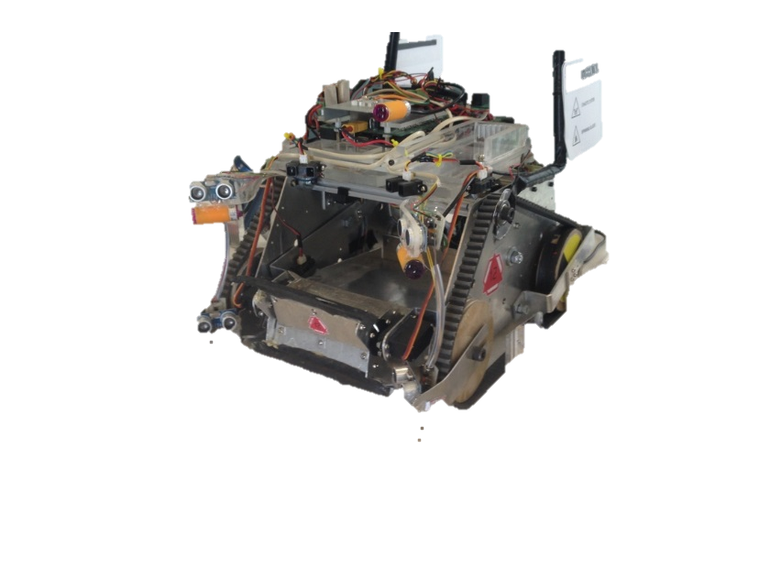Group 12 employed the use of a combine harvester sweeping collection mechanism which would grab hold of the packages and sweep them on board the robot (Figure 7). This mechanism worked well as it could pick up packages even if they were not detected by the ultrasonic sensors. Because of this, the travelling speed of this robot was much faster than most robots, being approximately. Obstacle detection was achieved by long range IR sensors, variable IR sensors and high velocities.

Much the same as Groups 3 and 4, package detection was achieved by ultrasonic signal comparison. Packages could be detected between and. The robot had a field-of-view of approximately 50 degrees either side of the centre line. Detection of package wasn't very accurate, but this group did end up collecting the most package overall and hence the greatest mass. Once packages were detected, the robot simply drove at the package. If the package became jammed, then it could be ejected by reversing the pickup mechanism. Pickup time was between 0.5 and 2 seconds. Once three packages were on board then the robot used the IMU to return to base via the built in magnetometer.

Figure 7: Group 12 robot

This design worked well during the competition as it could pick up package in any orientation and return to HQ once three packages were collected. This design could have been significantly improved with a more accurate package detection mechanism. Our robot could have benefited significantly by using the IMU to return to HQ once three packages were detected, the only issue could have been the permanent magnets interfering with the IMU magnetometer. Overall this robot deserved a higher placing than it achieved in the competition.

## 4.4 Competitor 4 (Group 6)

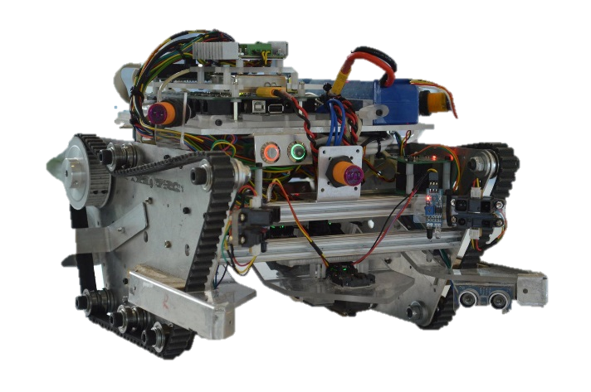Group 6 employed the use of a slotted pick up mechanism which swept the packages on board and held them via their groves (Figure 8). The robot would align itself with the package, then the smart servo controlled bar would sweep the package up the slot and store the package at the rear of the robot. This was a fairly slow robot, so a travel speed of would be a good approximate. Obstacle detection was achieved through an array of IR sensors.

Figure 8: Group 6 robot

Package detection used ultrasonic sensors similar to the other groups evaluated in this report. The difference being that the ultrasonic signal was compared with short and long range IR sensors mounted above. This robot was supposed to have been able to detect packages from to, but this would seem to be a very optimistic estimate. Once a package was detected, the robot took approximately five seconds to drive to the package and collect it. This design was limited by the fact that it could only retrieve packages that were upright and not obstructed by obstacles.

Similarities to our robot was seen in the comparison of signals between the infrared and ultrasonic sensors. During the competition, this robot struggled to manoeuvre over terrain. However, its package detection and pick up mechanism seemed to work well when packages were lined up. Overall this robot operated adequately and achieved second place in the competition, but improvements to locomotion would have further helped this robot.

## 4.5 Design Improvements

During the competition, the robot lost a total of two times. These were due to a number of issues that could be improved on in order to produce a winning robot. The first round lost was to Group 3 when our robot became locked with the opposing robot. The round came to an end after five minutes, and they won as they were further from their base – both robots carried the same mass. It is difficult to prevent robots locking together, and it is even more difficult to program them to separate once it has occurred (which our robot did). The best way to avoid this would be to have better sensor placement in order to avoid collision with the opposition's robot. Overall better package detection and sensor placement would have avoided this loss.

More reliable package detection would improve many aspects of this robot. Currently, the use of ultrasonic sensors to detect packages has issues with false detections caused by arena obstacles. These false detections caused the robot to waste time looking for packages and caused the robot to become stuck at several points during the competition. This could be achieved via several different methods that are within the boundaries of the competition. Computer vision could be used to navigate as well as look for packages, as the brass colour is quite distinctive. Another option would be the use of an IR diode coupled with an IR camera. The package in the arena would reflect the IR wavelengths and appear as bright spots within the arena. These bright spots could be picked up by the IR camera, allowing the robot to hone in on the package. Both these options should definitely be investigate further to produce a better performing robot.

The second loss occurred when facing Group 6. The opposition robot became stuck in front of our robot on top of uneven terrain. Our robot, without a reliable watchdog timer, continued to drive into the opposition robot thinking that it was collecting a package. This could be avoided through the use of a watchdog timer that used the accelerometer. If the robot hadn't moved for 10 seconds then it would trigger the timer to reverse, turn, and drive away. If our robot backed up from getting stuck, it would have been likely to collect more packages.

# 5.0 Conclusion

In conclusion, the robot designed by Group 10 for the Robocup competition was a well-rounded robot that had good potential. It had an effective and unique track layout, allowing the robot to move fairly quickly and efficiently over all terrain, and the robot also possessed one of the two most efficient methods of package collection.

Although this robot had these effective systems, there were several weaknesses this robot had which caused the robot to fail twice – and lose the tournament. There are two primary changes that have been identified as most important, one of which would require much re-working, and the other which would only require several hours to implement. The package detection method of using a difference in sensor values was not sufficient, but should be complimented with a larger variety of sensors, and the watchdog timer would have been made more effective by using accelerometer values as well.

Throughout the course of designing and constructing this robot, many lessons have been learnt, and many tasks would be done differently next time. Although our robot did not win the Robocup, it has been an all-round positive experience for the whole team.

# Contribution statements

Ryan Taylor

* Report writing and formatting
* CAD modelling/drawing
* Pickup mechanism design, calculations, Matlab coding and build/machine
* Material/Parts sourcing
* Circuit 3 (LED Array) design and build
* Software logic and testing

Jack Hendrikz

* Report writing and formatting
* Design and building of electrical module (sensor circuit layout and wiring)
* Quick release mechanism design
* Circuit 1 (Audio Amplifier) design and build
* General testing, coding and debugging

Peter Nicholls

* Report proof-reading and formatting
* Electrical to Software interfaces
* Navigation algorithm research
* Software design and implementation
* Circuit 2 (Switch bank) design and build

# Appendix 1 – Bill of Materials

## Bill Of Materials (Provided)

|  |  |  |
| --- | --- | --- |
| Item | Quantity | Total Cost (NZ dollar) |
| Aluminium plate | 2 | 32.00 |
| Aluminium extrusion | 4 | Not priced |
| Sensor Circuits | 4 | Not priced |
| Arduino Mega ADK | 1 | 60.00 |
| Lithium Battery | 1 | Not priced |
| Ultrasonic Sensor | 2 | 2.00 |
| Medium Infrared Sensor | 2 | 38.00 |
| Long Infrared Sensors | 1 | 17.00 |
| Cables | NA | Not priced |
| 3D Printed Wheel | 4 | Not priced |
| Smart Servo | 1 | 50.00 |
| DC motor | 2 | 106.00 |
| Drive Wheel | 2 | Not priced |
| Bearing (29mm) | 16 | Not priced |
| M3 Cap Screws | NA | Not priced |
| M8 Cap Screws | 10 | Not priced |
| Aluminium 15mm 40x100 | 1 | 5 |
| Aluminium 5mm 120x100 | 1 | 10 |
| Aluminium 2mm 300x200 | 1 | 5 |
| Steel rod 1/4 inch 200mm | 1 | 1 |
| Steel rod 10mm 100mm | 1 | 0.5 |
| Spring 20mm compressive | 1 | 0.1 |
| Perspex 10mm 200x350 | 1 | Not priced |
| Perspex 4mm 200x150 | 1 | Not priced |
| M3 | 40 | 4 |
| M5 | 4 | 0.75 |
| Geared Stepper | 2 | 30 |
| Digital IR | 3 | 15 |

## Bill of Materials (Additional)

|  |  |  |
| --- | --- | --- |
| Item | Quantity | Total Cost (NZ dollar) |
| Ultrasonic sensor | 1 | $2.50 |
| Permanent Magnets | 3 | 30.00 |
| Total Cost | | **$32.50** |

## Bill Of Materials (Circuit 1)

|  |  |  |
| --- | --- | --- |
| Item | Quantity | Cost (NZ dollar) |
| 1000 uF/ 25V electro cap | 1 | 0.22 |
| 10 uF/ 25V electro cap | 1 | 0.10 |
| 0.22 uF/ 25V electro cap | 1 | 0.10 |
| 100 n cap | 1 | 0.05 |
| 47 n cap | 1 | 0.40 |
| IC LM386 | 1 | 0.08 |
| 10k variable resistor | 1 | 0.33 |
| 10 Ω resistor | 1 | 0.02 |
| 1 W speaker | 1 | 1.50 |
| Total Cost | | **$2.80** |

## Bill Of Materials (Circuit 2)

|  |  |  |
| --- | --- | --- |
| Item | Quantity | Cost (NZ dollar) |
| SW DIP-8 | 1 | 2.51 |
| RJ45 8P8C jack | 2 | 0.50 |
| Resistor 10K | 8 | 0.02 |
| Total Cost | | **$3.67** |

## Bill Of Materials (Circuit 3)

|  |  |  |
| --- | --- | --- |
| Item | Quantity | Cost (NZ dollar) |
| IR LED | 6 | 0.20 |
| 220 Ω resistor | 6 | 0.02 |
| Header pin | 2 | 0.10 |
| Switch | 1 | 3.00 |
| Total Cost | | **$4.52** |

# Appendix 2 – Tournament Placings

|  |  |  |  |
| --- | --- | --- | --- |
| Group | Place | Total mass (kg) | Rounds contested |
| 1 | 10= | 0.75 | 2 |
| 2 | 10= | 0 | 2 |
| 3 | 3 | 3.75 | 5 |
| 4 | 7= | 3.25 | 4 |
| 5 | 10= | 0 | 2 |
| 6 | 2 | 6.5 | 8 |
| 7 | 7= | 3.25 | 4 |
| 8 | 10= | 0.75 | 2 |
| 9 | 5= | 1.5 | 4 |
| 10 | 4 | 5.25 | 4 |
| 11 | 1 | 6.5 | 6 |
| 12 | 5= | 6.75 | 4 |
| 13 | 9 | 1 | 3 |